# TITLE OF Project

**A Project Report *Submitted by***

## Shivam Bharadwaj

## Shubham Singh

## Divit Sinha

## Sarvesh Kulkarni

***Under the Guidance of***

## Snehal K

***in partial fulfilment for the award of the degree of***

## Master of Business Administration in Technology Management

**IN BRANCH OF STUDY**

## At



**NAME OF COLLEGE & UNIVERSITY, PLACE**

**March, 2019**

## DECLARATION

I, Shivam Bharadwaj, Shubham Singh, Divit Sinha, Sarvesh Kulkarni , Roll No. N006, N052, N053,N062 B.Tech/MBATech/B.Tech Integrated (Computer Engineering), IV/VI semester understand that plagiarism is defined as anyone or combination of the following:

1. Un-credited verbatim copying of individual sentences, paragraphs or illustration (such as graphs, diagrams, etc.) from any source, published or unpublished, including the internet.
2. Un-credited improper paraphrasing of pages paragraphs (changing a few words phrases, or rearranging the original sentence order)
3. Credited verbatim copying of a major portion of a paper (or thesis chapter) without clear delineation of who did wrote what. ( Source:IEEE, The institute, Dec. 2004)
4. I have made sure that all the ideas, expressions, graphs, diagrams, etc., that are not a result of my work, are properly credited. Long phrases or sentences that had to be used verbatim from published literature have been clearly identified using quotation marks.
5. I affirm that no portion of my work can be considered as plagiarism and I take full responsibility if such a complaint occurs. I understand fully well that the guide of the seminar/ project report may not be in a position to check for the possibility of such incidences of plagiarism in this body of work.

Signature of the Students:

Names: Shivam Bharadwaj, Shubham Singh, Divit Sinha, Sarvesh Kulkarni

Roll Nos. N006, N052, N053,N062

Place: Mumbai

Date: 29 March 2019

## CERTIFICATE

This is to certify that the project entitled “ Statistical Analysis Of Criminal Database ” is the bonafide work carried out by Shivam Bharadwaj, Shubham Singh, Divit Sinha, Sarvesh Kulkarni of B.Tech/B.Tech Integrated/MBATech, MPSTME (NMIMS), Mumbai, during the IV semester of the academic year 2018-2019 , in partial fulfilment of the requirements for the Course Programming Laboratory II/ Implementation of Technology.

Snehal K

Internal Mentor

_______________________ ________________________

Examiner 1 Examiner 2

**Acknowledgement**

In preparation of my project, I had to take the help and guidance of some respected persons, who deserve my deepest gratitude. As the completion of this assignment gave me much pleasure, I would like to show my gratitude Snehal K for giving me a good guidelines for assignment throughout numerous consultations. I would also like to expand my gratitude to all those who have directly and indirectly guided me in writing this assignment.

In addition, a thank you to Professor Prathamesh C, who gave invaluable advice on the improvement of the project. Many people, especially my classmates have made valuable comment suggestions on our project which gave me an inspiration to improve the quality of the project.

## Table of contents

**CHAPTER NO. TITLE PAGE NO.**

1. INTRODUCTION
2. SOFTWARES AND API USED WITH DESCRIPTION
3. METHODS IMPLEMENTED
4. SCREENSHOTS
5. CONCLUSION & FUTURE SCOPE
6. SOCIETAL APPLICATION

## Introduction

The purpose of this project is to develop a software which involves citizens as users by keeping them aware of the criminal activities in their locality, taking their opinions and bringing them together to collaborate and find a creative solution to problems. Further, it is our aim to generate a user-fed database which updates crime statistics based on user entries.

The scope of the project is only limited by the participating and active users. At present the aim is to integrate the use of the software throughout the city of Mumbai. It is beneficial to involve as many people as possible. They are the potential stakeholders.

The project has a feature for instant messaging, location mapping, database management and statistical representation of data.

In short, people input information in the software by means of text threads in chats, survey and location information. The software gives crime statistics to the user and helps gain information from other users in the vicinity.

**Software and API**

**Software**

Computer software, or simply software, is a collection of data or computer instructions that tell the computer how to work. This is in contrast to [physical hardware](https://en.wikipedia.org/wiki/Computer_hardware), from which the system is built and actually performs the work. In [computer science](https://en.wikipedia.org/wiki/Computer_science) and [software engineering](https://en.wikipedia.org/wiki/Software_engineering), computer software is all [information](https://en.wikipedia.org/wiki/Information) processed by [computer systems](https://en.wikipedia.org/wiki/Computer_system), [programs](https://en.wikipedia.org/wiki/Computer_program) and [data](https://en.wikipedia.org/wiki/Data). Computer software includes [computer programs](https://en.wikipedia.org/wiki/Computer_program), [libraries](https://en.wikipedia.org/wiki/Library_(computing)) and related non-executable [data](https://en.wikipedia.org/wiki/Data_(computing)), such as [online documentation](https://en.wikipedia.org/wiki/Software_documentation) or [digital media](https://en.wikipedia.org/wiki/Digital_media). Computer hardware and software require each other and neither can be realistically used on its own.

Softwares used in this project are:

1. Android Studio

Android Studio is the official [integrated development environment](https://en.wikipedia.org/wiki/Integrated_development_environment) (IDE) for [Google](https://en.wikipedia.org/wiki/Google)'s [Android](https://en.wikipedia.org/wiki/Android_(operating_system)) [operating system](https://en.wikipedia.org/wiki/Operating_system), built on [JetBrains](https://en.wikipedia.org/wiki/JetBrains)' [IntelliJ IDEA](https://en.wikipedia.org/wiki/IntelliJ_IDEA) software and designed specifically for [Android development](https://en.wikipedia.org/wiki/Android_software_development). Android Studio supports all the same programming languages of [IntelliJ](https://en.wikipedia.org/wiki/IntelliJ) (and [CLion](https://en.wikipedia.org/wiki/CLion)) e.g. [Java](https://en.wikipedia.org/wiki/Java_(programming_language)), [C++](https://en.wikipedia.org/wiki/C%252B%252B), and more with extensions, such as [Go](https://en.wikipedia.org/wiki/Go_(programming_language)); and Android Studio 3.0 or later supports [Kotlin](https://en.wikipedia.org/wiki/Kotlin_(programming_language)) and "Java 7 language features and a subset of Java 8 language features that vary by platform version.”External projects [backport](https://en.wikipedia.org/wiki/Backporting) some Java 9 features.While IntelliJ that Android Studio is built on supports all released Java versions, and Java 12, it's not clear to what level Android Studio supports Java versions up to Java 12 (the documentation mentions partial Java 8 support). At least some new language features up to Java 12 are usable in Android.

1. Google Developers Console

Google Developers (previously Google Code) is [Google](https://en.wikipedia.org/wiki/Google)'s site for [software development](https://en.wikipedia.org/wiki/Software_development) tools, [application programming interfaces](https://en.wikipedia.org/wiki/Application_programming_interface) (APIs), and technical resources. The site contains documentation on using Google developer tools and APIs—including discussion groups and blogs for developers using Google's developer products.

There are APIs offered for almost all of Google's popular consumer products, like [Google Maps](https://en.wikipedia.org/wiki/Google_Maps), [YouTube](https://en.wikipedia.org/wiki/YouTube), [Google Apps](https://en.wikipedia.org/wiki/Google_Apps), and others. The site also features a variety of developer products and tools built specifically for developers. [Google App Engine](https://en.wikipedia.org/wiki/Google_App_Engine) is a hosting service for web apps. Project Hosting gives users version control for [open source](https://en.wikipedia.org/wiki/Open-source_software) code. [Google Web Toolkit](https://en.wikipedia.org/wiki/Google_Web_Toolkit) (GWT) allows developers to create [Ajax](https://en.wikipedia.org/wiki/Ajax_(programming)) applications in the [Java programming language](https://en.wikipedia.org/wiki/Java_(programming_language)).

1. Firebase

Firebase provides a realtime database and backend as a service. The service provides application developers an API that allows application data to be synchronized across clients and stored on Firebase's cloud

**API**

1. Google Maps

By using the Google Maps [API](https://en.wikipedia.org/wiki/Application_programming_interface), it is possible to embed Google Maps into an external website or application, on to which specific data can be overlaid.

1. Google Maps Places

The functions in the Places Library, Maps JavaScript API enable your application to search for places (defined in this API as establishments, geographic locations, or prominent points of interest) contained within a defined area, such as the bounds of a map, or around a fixed point.

1. Firebase Auth

Firebase Auth is a service that can authenticate users using only client-side code. It supports [social login providers](https://en.wikipedia.org/wiki/Social_login) Facebook, GitHub, Twitter and Google (and [Google Play Games](https://en.wikipedia.org/wiki/Google_Play_Games)). Additionally, it includes a user management system whereby developers can enable user authentication with email and password login stored with Firebase.

1. Firebase Database

Firebase provides a realtime database and backend as a service. The service provides application developers an API that allows application data to be synchronized across clients and stored on Firebase's cloud.

1. Google Play Service

With Google Play services, an app can take advantage of the latest, Google-powered features such as Maps, Google+, and more, with automatic platform updates distributed as an APK through the Google Play store. This makes it faster for your users to receive updates and easier for you to integrate the newest that Google has to offer.

**Methods Implemented**

A Method provides information about, and access to, a single method on a class or interface. The reflected method may be a class method or an instance method (including an abstract method).

A Method permits widening conversions to occur when matching the actual parameters to invoke with the underlying method's formal parameters, but it throws an IllegalArgumentException if a narrowing conversion would occur.

1. Google Maps

By using the Google Maps [API](https://en.wikipedia.org/wiki/Application_programming_interface), it is possible to embed Google Maps into an external website or application, on to which specific data can be overlaid.

1. MPAndroidChart

It is a free Android chart view / graph view library using which you can draw line, bar, pie, radar, bubble, candlestick charts, etc.

**Screenshots**

**Splash Screen 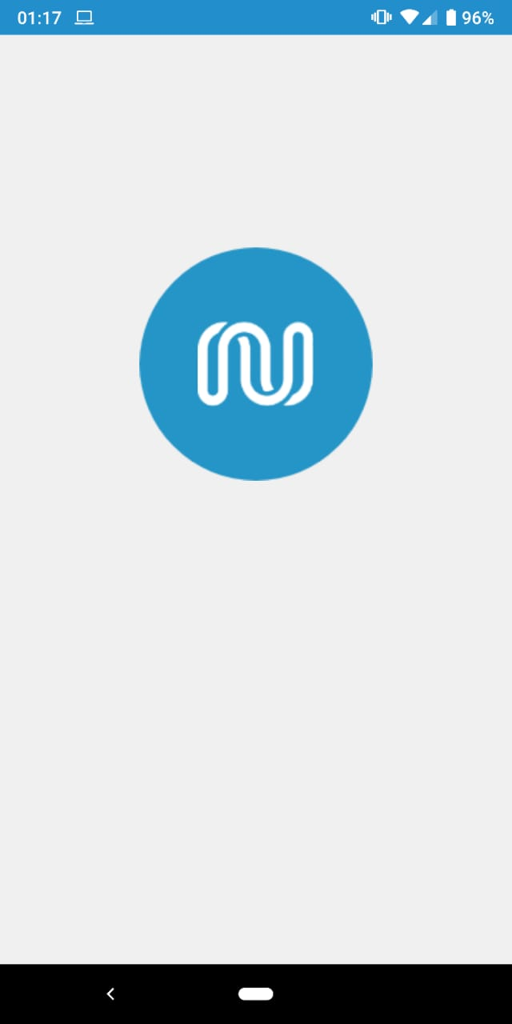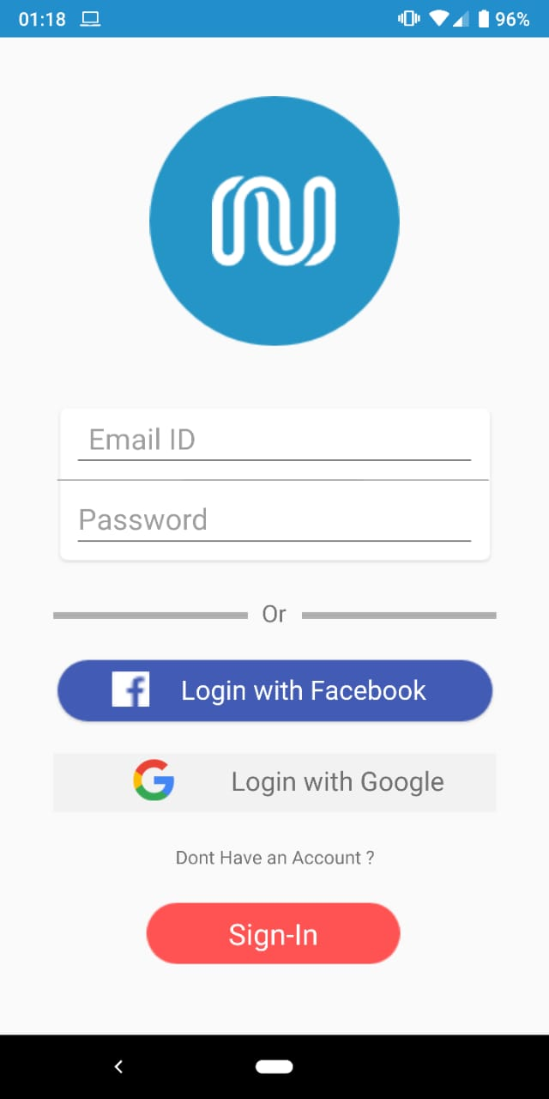 SignIn**

**SignUp 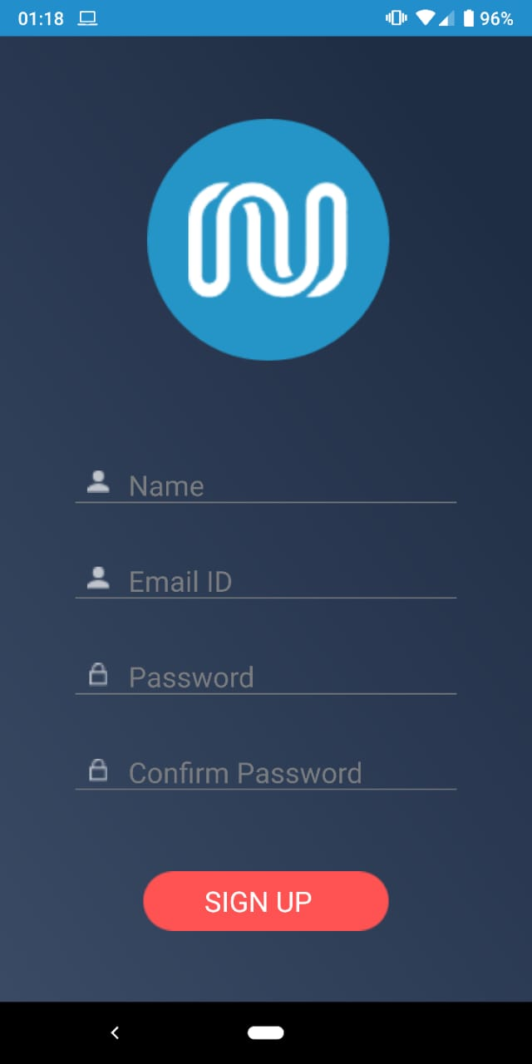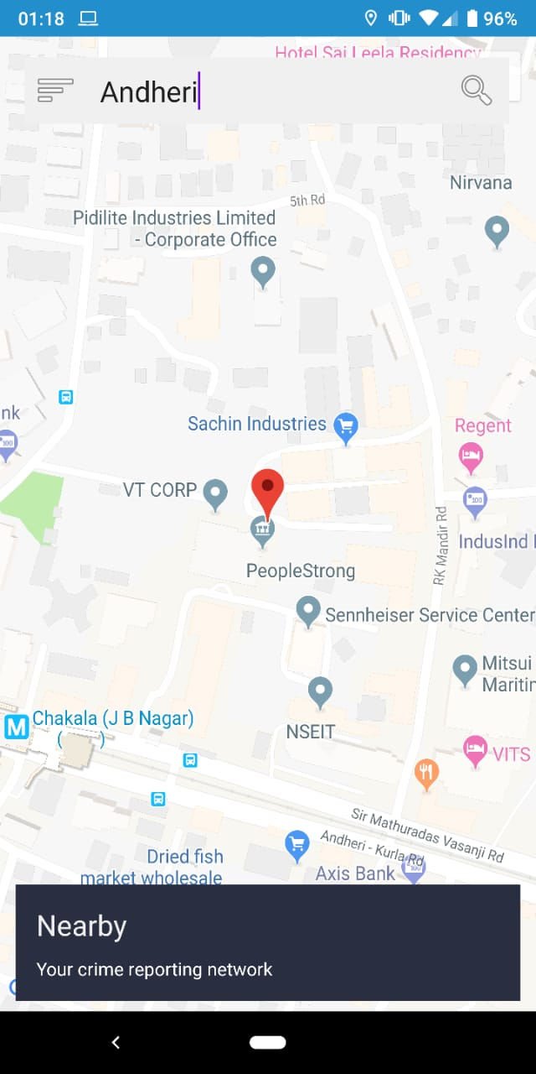 Map Area**

**Menu 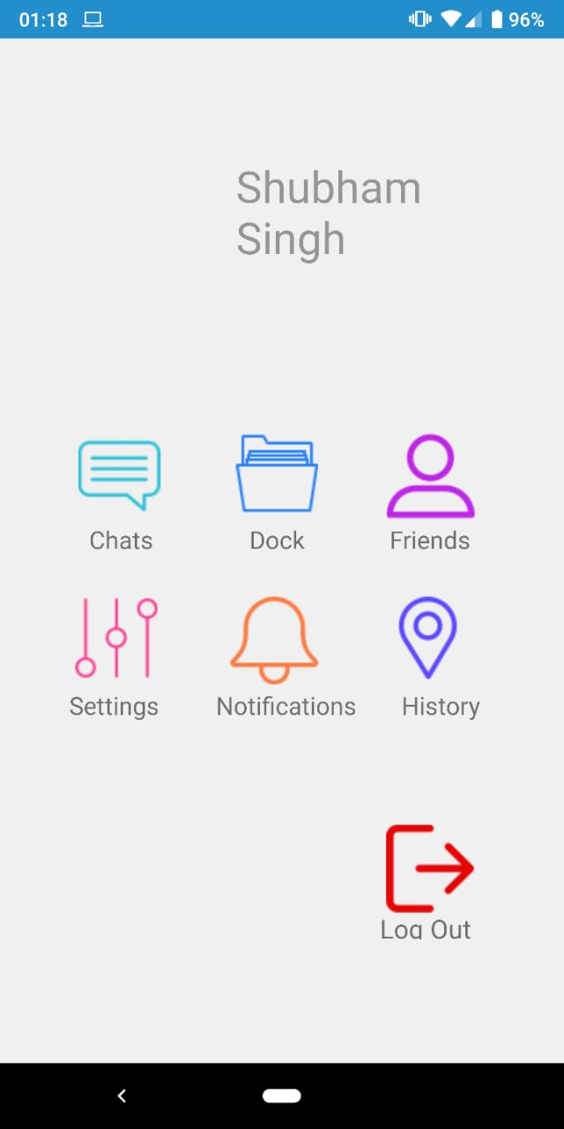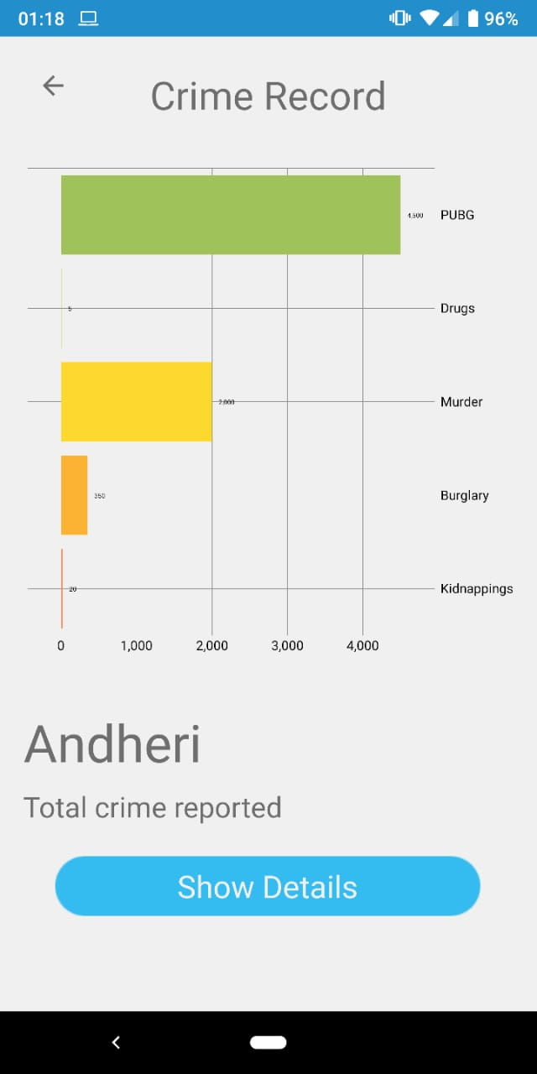 Statistical Analysis**

**Chat Thre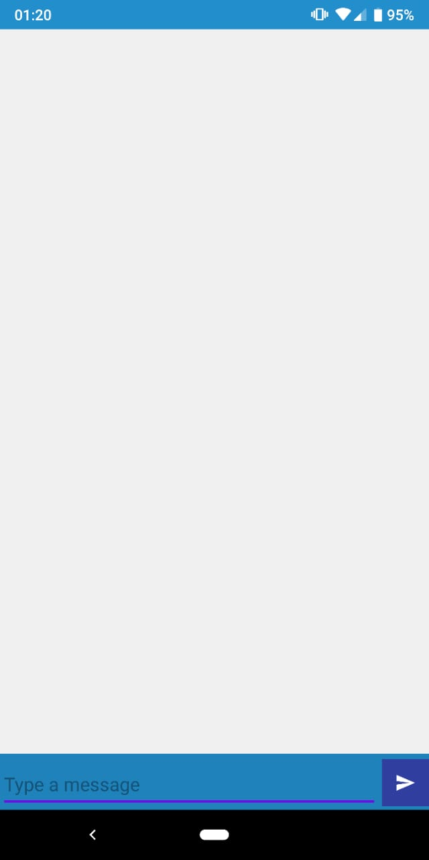ads**

Firebase

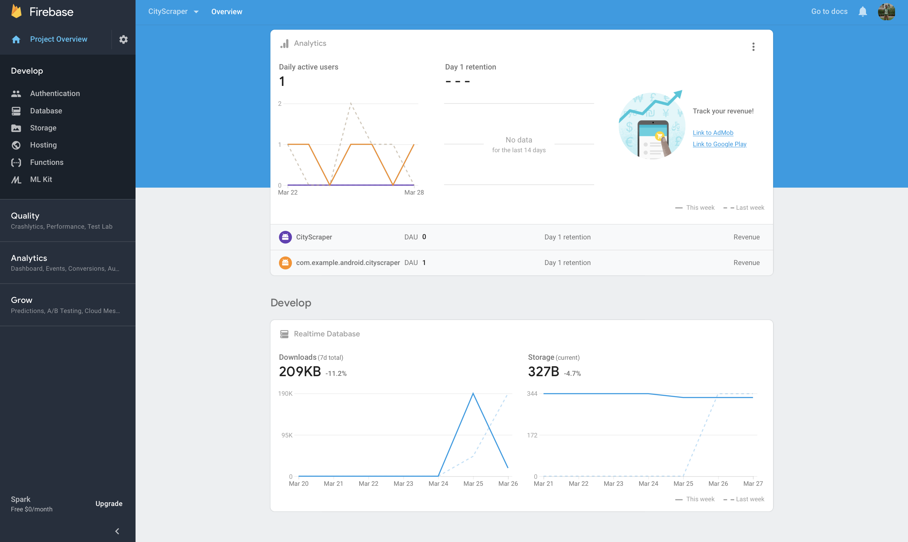

Real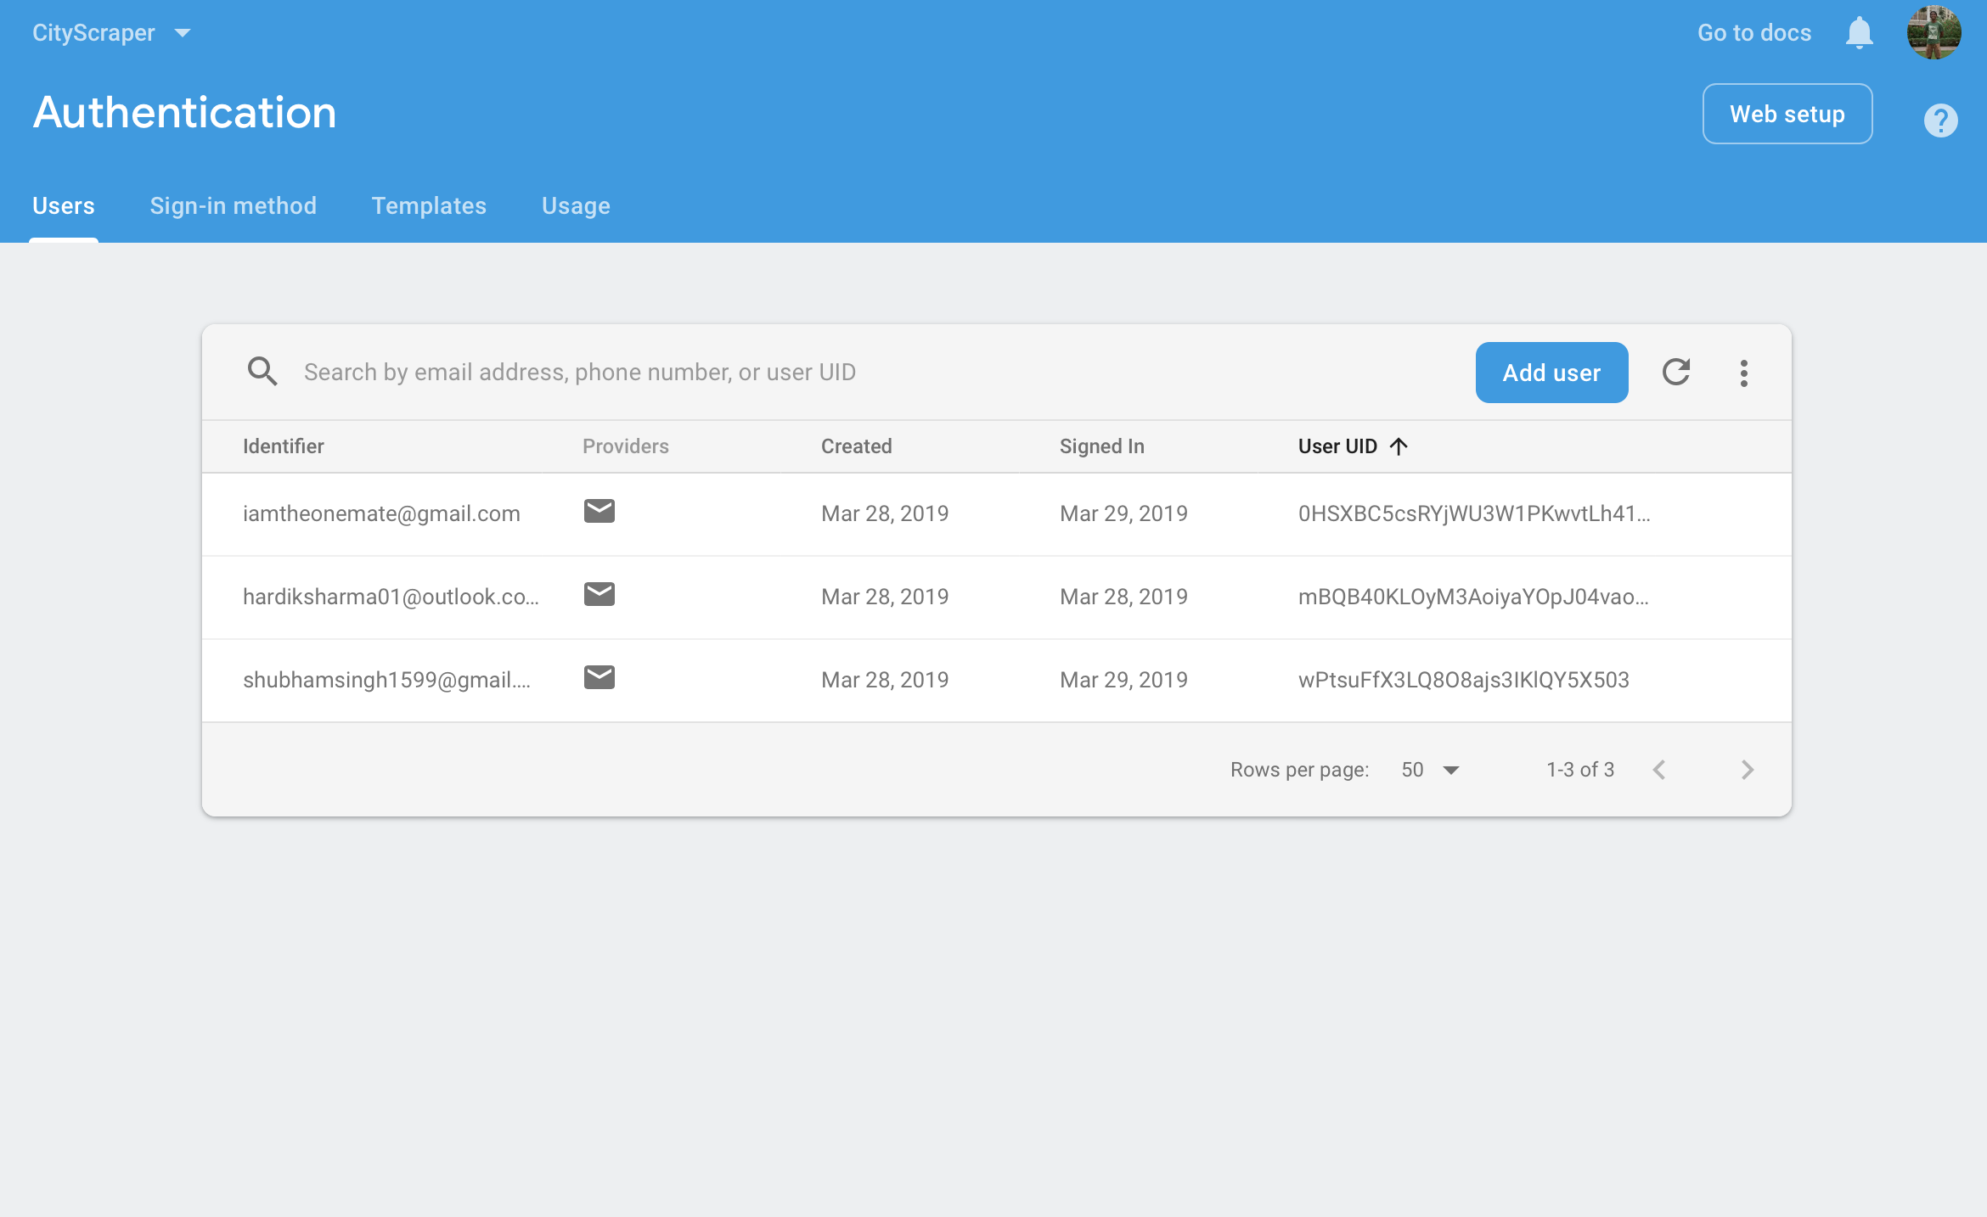time Database

Authentication Data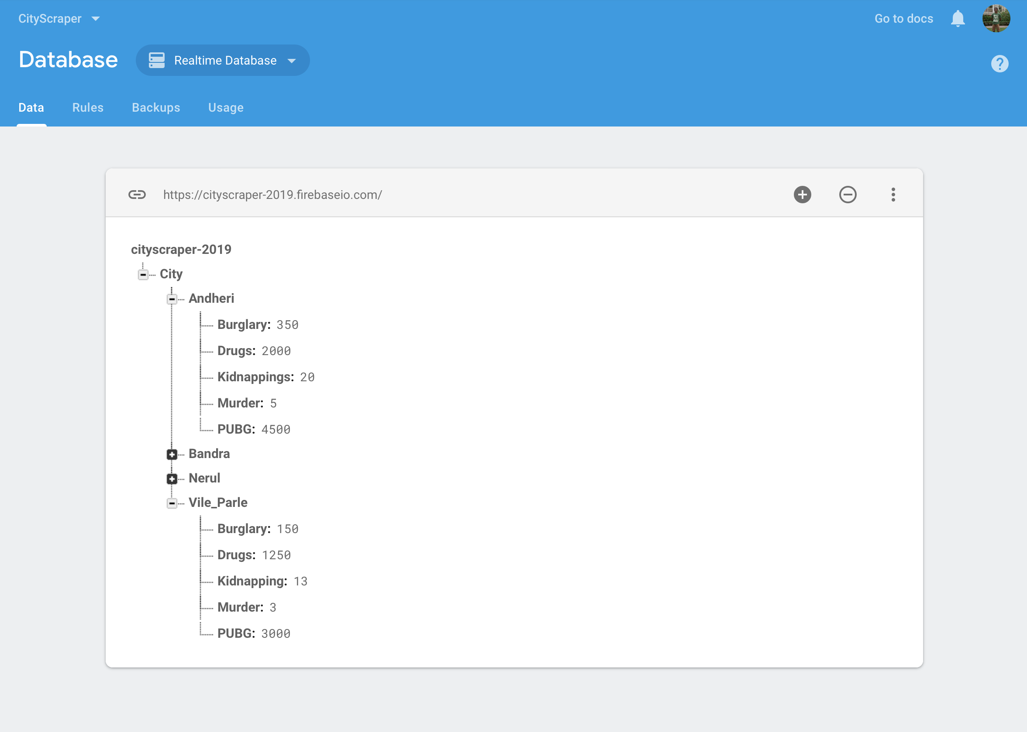

**Conclusion and Scope**

**Conclusion**

The purpose of this project is to develop a software which involves citizens as users by keeping them aware of the criminal activities in their locality, taking their opinions and bringing them together to collaborate and find a creative solution to problems. Further, it is our aim to generate a user-fed database which updates crime statistics based on user entries.

**Scope**

1. Stakeholders  
   The scope of the project is only limited by the participating and active users. At present the aim is to integrate the use of the software throughout the city of Mumbai. It is beneficial to involve as many people as possible. They are the potential stakeholders.
2. Project Scope  
   The project needs a feature for instant messaging, location mapping, database management and statistical representation of data.
3. Process Scope  
   In short, people input information in the software by means of text threads in chats, survey and location information. The software gives crime statistics to the user and helps gain information from other users in the vicinity.

**Societal Application**

1. Check the crime rate in an area
2. Get live feeds of people on the current crimes in the area
3. Conduct surveys to get / outsource solutions from the crowd
4. Conduct surveys to get / outsource solutions from the crowd
5. Secondary Source of information (Criminal Database)
6. Platform for people to connect